OUTPUT:

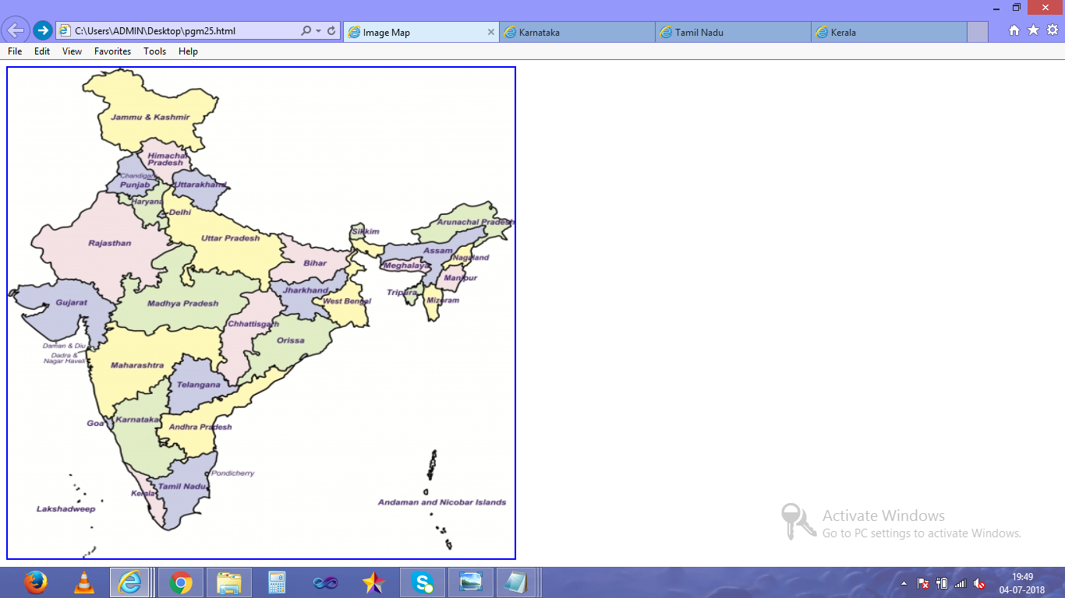

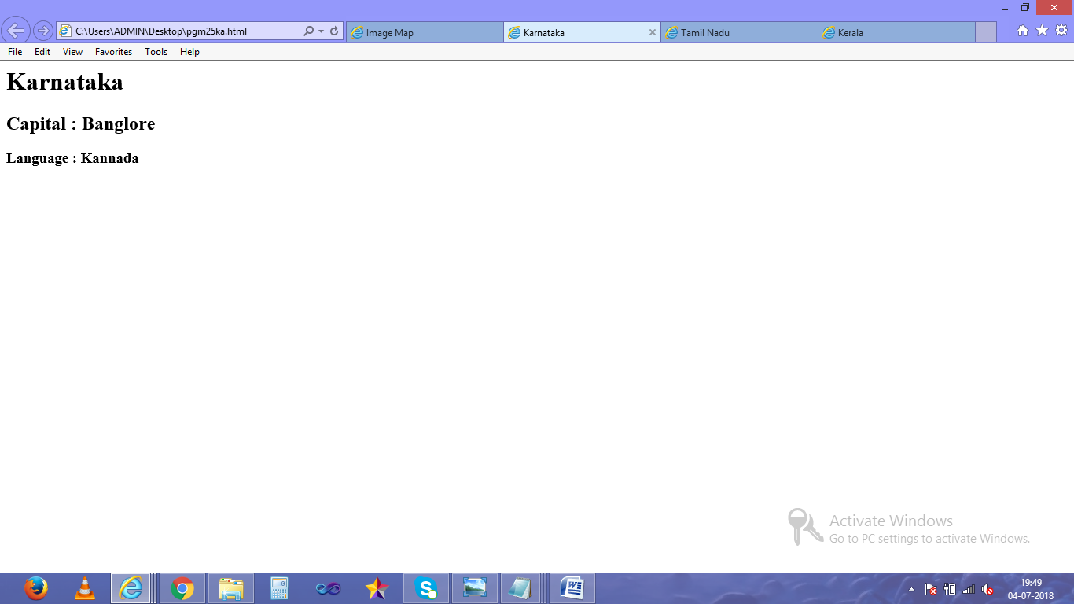

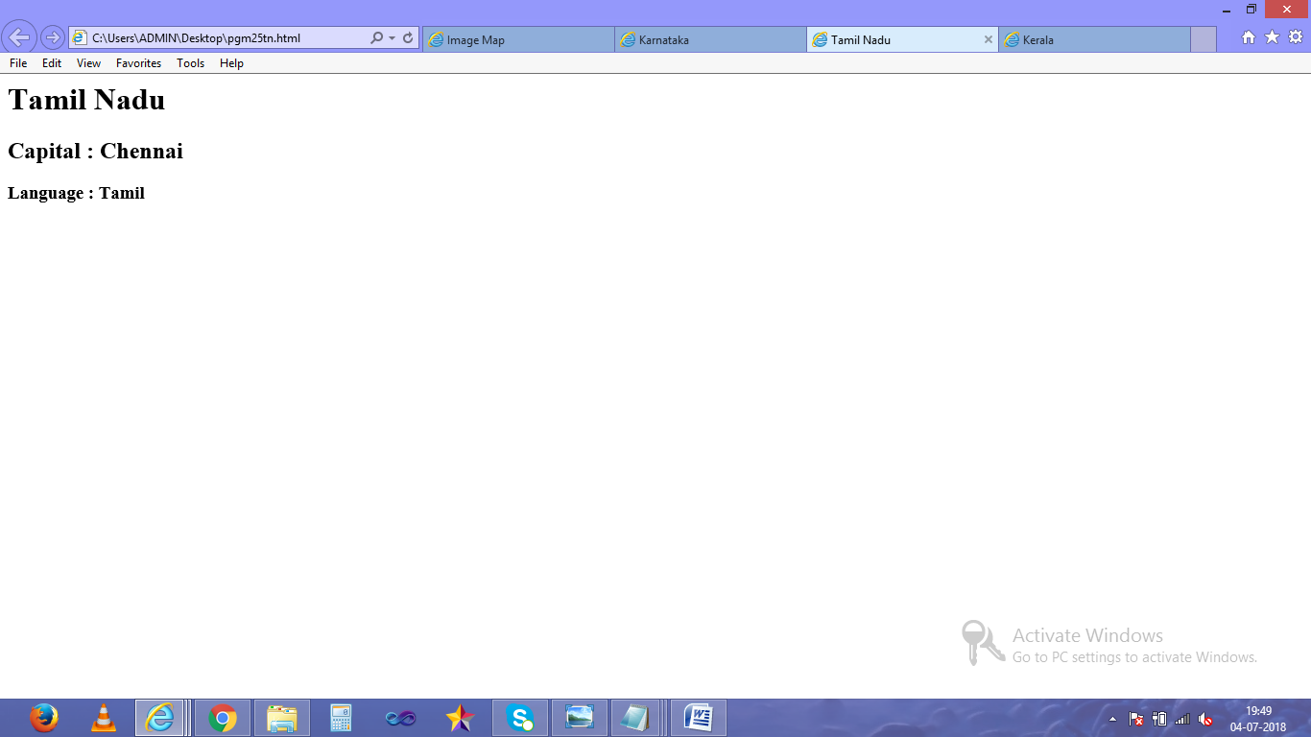

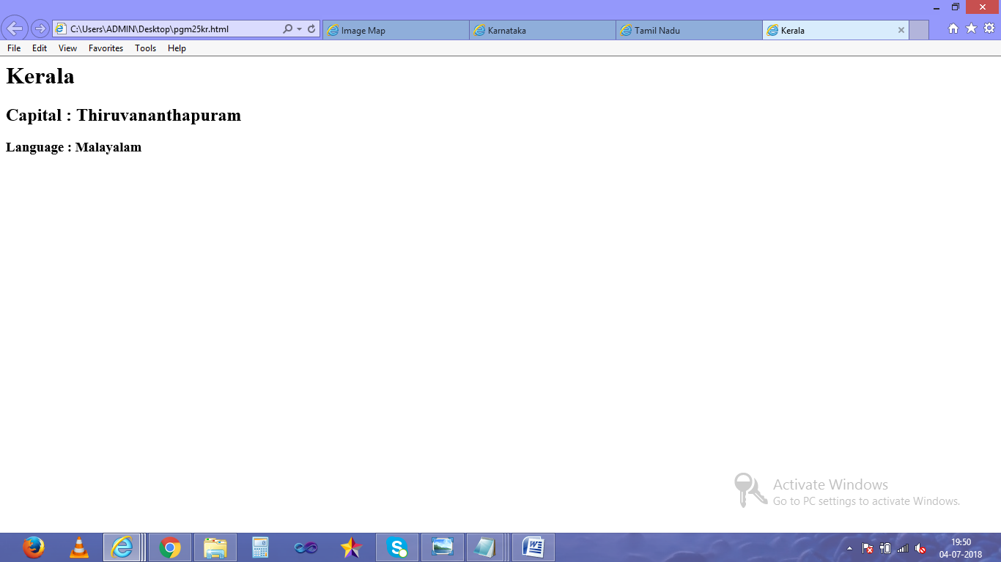

RESULT:

PROGRAM:

<html>

<head>

<title>Image Map </title>

</head>

<body>

<img src="india2.jpg" height="630" width="650" usemap="#indiamap">

<map name="indiamap">

<area shape="rect" coords= "269,287,362,329" href="C:/Users/ADMIN/Desktop/pgm25tn.html">

<area shape="rect" coords= "218,349,259,360" href="C:/Users/ADMIN/Desktop/pgm25kr.html">

<area shape="rect" coords= "169,178,245,248" href="C:/Users/ADMIN/Desktop/pgm25ka.html">

</map>

</body>

</html>

PROGRAM:

<html>

<head>

<title>Tamil Nadu</title>

</head>

<body align ="center">

<h1>Tamil Nadu </h1>

<h2>Capital : Chennai </h2>

<h3>Language : Tamil </h3>

</body>

</html>

PROGRAM:

<html>

<head>

<title>Kerala </title>

</head>

<body allign="center">

<h1>Kerala </h1>

<h2>Capital : Thiruvananthapuram </h2>

<h3>Language : Malayalam </h3>

</body>

</html>

PROGRAM:

<html>

<head>

<title>Karnataka</title>

</head>

<body allign="center">

<h1>Karnataka </h1>

<h2>Capital : Banglore</h2>

<h3>Language : Kannada</h3>

</body>

</html>